LINDSAY PARK
49 Thames Street
West Wollongong NSW 2500
Telephone: (02) 4229 2487
Web: www.lindsaypk-p.schools.nsw.gov.au
Email: lindsaypk-p.school@det.nsw.edu.au

Public School

14 July 2021
Dear Parents and Carers,

Sadly, as announced today by the Premier, schools in Greater Sydney will continue to operate on Level 4 restrictions until at least 30 July. For our school, this means we will continue to support students to learn from home and provide supervision of learning on site for those who really need it.

We appreciate everything our families are doing to enable learning from home for their children. I know it is not an easy task, particularly if you are balancing your own work from home commitments. One of the priorities the school has been tasked with is to ensure minimal staff on site ach day. This is difficult if student numbers at school are high.

We are hopeful that with the experience from 2020 under our belts, we can move into the next two weeks with some confidence. The information below will help to guide our families regarding school organisation for at least the next two weeks of Level 4 learning from home restrictions.

Borrowing school devices
To provide all of our students with the opportunity to connect online, we are loaning school laptops and iPads to families who do not have a device for their child/ren.
Collection from the school will be made via the Kiss and Drop Thames Street gate. Please park in the zone and ask your child to come into the school to collect the device and log in. Parents are asked to remain in their cars. Staff will be waiting under the shelter near the gate and will assist students to login and complete the paperwork. Your signature is required, so when the process is complete, a staff member will come to your car for you to sign out the device. It would be appreciated if you can wear a mask at this time.

Paper learning pack collection times
Teachers will develop paper learning packs each week for those families who have indicated they are using them. These will be available for collection each Monday morning between 9-9.30am. Please pull into the Kiss and Drop zone, stay in your car and a staff member will be there to hand you the relevant pack/s. At this time, it is expected that the work from the previous week is handed in to the school. It would be appreciated if you can wear a mask at this time.

School Supervision
Students who need to come to school for supervision will complete the same learning from home program as all other students. Teachers will be rostered on supervision one day per week. Please be aware that teachers need to balance this supervision schedule with their online learning platform from home. We are supervising students in stage groups to minimise mingling between age groups and enable productive supervision. Students need to bring food and a drink bottle as there is no canteen or bubbler facilities. If they have a paper learning pack they will need to bring this in on the day and their own device, if they have one.

Learning from Home
Class online learning platforms will continue to operate as they have done this week. Moving into next week, all classes will be provided with one explicit learning opportunity per day. Often this will be a video that is pre-recorded so that students can access it at any time. Teachers will also endeavour to use various applications such as Zoom and Flip Grid to connect the class with one another. All learning from home information will be communicated directly by teachers from the class platform. Please make sure you are connected to your child’s teacher through their online class platform.

Below is the Department of Education recommended learning times for students of various ages. Please use this as a guide to set realistic expectations about how long students should be learning for at home, each day.

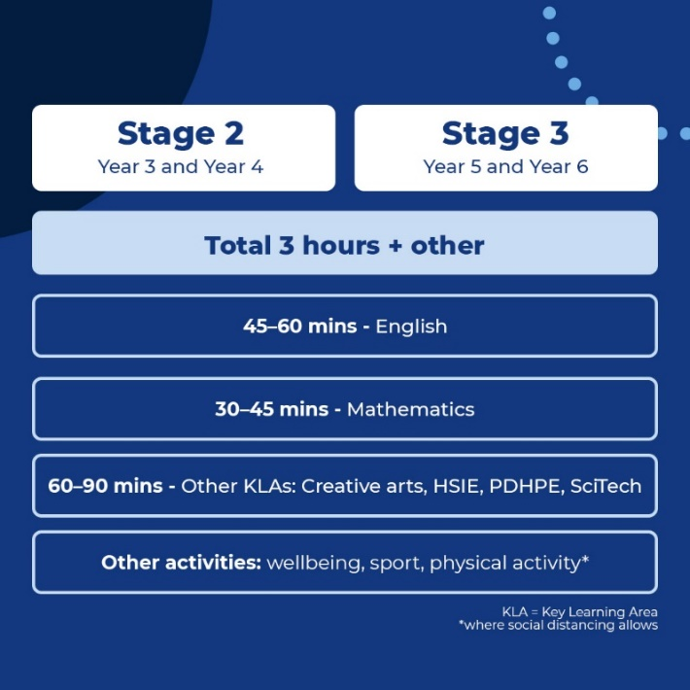
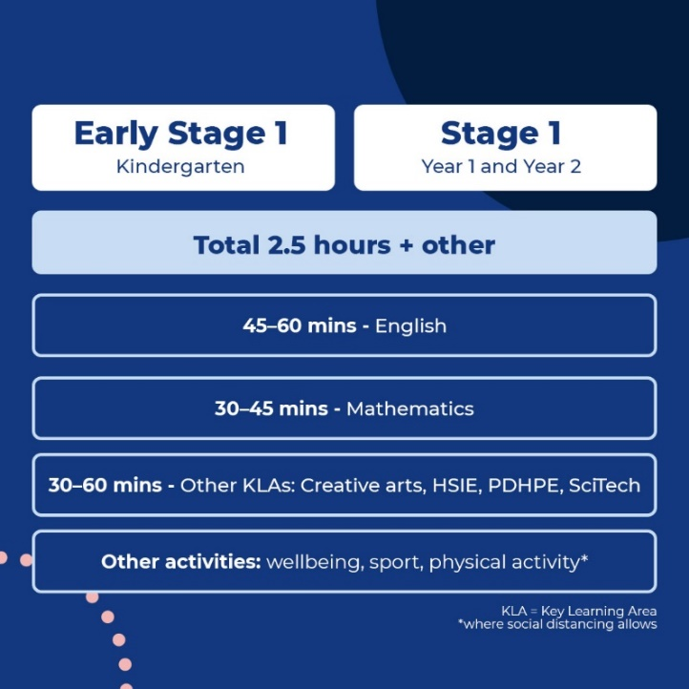

Attendance
Attendance will be marked according to the work they submit. A satisfactory submission would be one English and one Mathematics task per day. For those with paper packs, the provided work should be completed and returned the following week when the next pack is collected.

Learning Support and School Counsellor Service
We appreciate that this extension to learning from home may be confronting for many of our families. Provisions are available to access additional support for student wellbeing, learning and attendance. Please refer to the separate letter detailing the process for accessing these services.

Teachers Online
Each week, teachers will have time with the other teachers on their stage to collaboratively plan the following week’s learning. As a result, there will be one day a week when class teachers are offline. Students will still have work set for them but they will not be provided direct feedback on this day. You will be advised which day your child’s teacher is offline. All class teachers will be available on their platform for ‘live’ questions and support, four days a week: 9.30am – 10.30am and again at 12pm-1pm.

We are already impressed by the high number of students who have been engaging with their online learning and working through the tasks that have been provided. I want to acknowledge that this achievement is a wonderful reflection on the quality of the work provided by our dedicated staff, the commitment of our parents to support the learning from home program and of course our students.

It has certainly been a challenging time, with no doubt more challenges to come. I would like to take this opportunity to thank you for your ongoing support as we work together through this fast-moving period of change. Most importantly, I encourage you to look after those that are most important, including yourselves. There is a long road ahead and maintaining a focus on health and wellbeing at a time like this, will see us come through this stronger, both collectively and individually.

Stay safe and please do not hesitate to contact the school, via phone on 4229 2487 during school hours or through the school email, lindsaypk-p.school@det.nsw.edu.au, should you need our support.

Kind regards,

Jacqui Conway
Principal

